- Set a breakpoint, start debugging and check that code execution stops at this point.
- Set another breakpoint after the first one and disable it, check that the code execution does not stop on it when debugging continues ("Continue debugging" command or F5 hotkey) from the first breakpoint
- Set a conditional breakpoint and check that that code execution stops at this point. You can try this with the code of iterating the elements/rows of the collection, when the value from the condition is different for different elements/rows of the collection.
- Try using the "Step In", "Step Out", "Step Over" debug commands yourself with nested calls.
- Let's practice changing the value of a variable/object from debugging. To do this, create a general FormForDebugTest form, include it in the MasterData subsystem. Add the SendMessage command with the handler on the client to this form, display the command on the form as a button. Write this code in the handler procedure:
NumberForMessage = 1;
If NumberForMessage = 2 Then

Message("Number is " + NumberForMessage);

EndIf;
You can see that at the moment the condition will never be met. Your task is to start debugging and change the value of the NumberForMessage variable so that the condition is true. After that, the value must be changed again so that the message displayed to the user should be "Number is two, not one!" (not “Number is 2”).
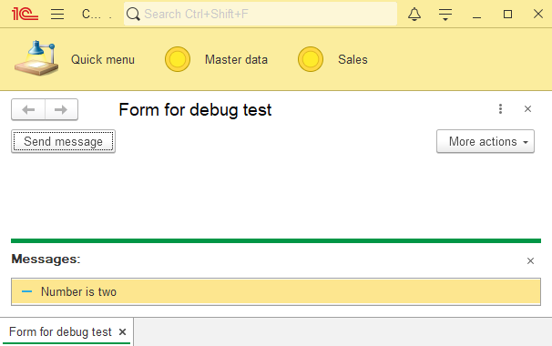
- Create another command in the form - CreateSalesInvoice, set its processing on the client, add the commande to the form. Copy the following code into the module of the FormForDebugTest form. Call CreateSalesInvoiceAtServer() from the new command’s client event handler. Update configuration, run the infobase at the Enterprise mode and click on the “Create sales invoice” button. You should see an error.
Also try to use the local variables window while debugging.

&AtServerNoContext
Procedure CreateSalesInvoiceAtServer()

BeginTransaction();
Try
Document = Documents.SalesInvoice.CreateDocument();

Document.Customer = NewCustomer();
Document.Contract = NewContract(Document.Customer);

FillProducts(Document);

Document.FillTotal();

CommitTransaction();
Except
RollbackTransaction();

//ErrorText = DetailErrorDescription(ErrorInfo());

Raise "An error occurred while creating the document";
EndTry;

EndProcedure

&AtServerNoContext
Function NewCustomer()

Customer = Catalogs.Counterparties.CreateItem();

Customer.Write();

Return Customer.Ref;

EndFunction

&AtServerNoContext
Function NewContract(Counterparty)

Contract = Catalogs.CounterpartyContracts.CreateItem();
Contract.Owner = Counterparty;

Contract.Write();

Return Contract.Ref;

EndFunction

&AtServerNoContext
Procedure FillProducts(SalesInvoice)

Query = New Query;
Query.Text =
"SELECT TOP 3
| Products.Ref AS Product
|FROM
| Catalog.Products AS Products
|WHERE
| NOT Products.DeletionMark
|
|ORDER BY
| Ref DESC";

QueryResult = Query.Execute();

If QueryResult.IsEmpty() Then
Return;
EndIf;

Selection = QueryResult.Select();
RowNumber = 0;
While Selection.Next() Do
RowNumber = RowNumber + 1;

NewRow = SalesInvoice.Products.Add();
NewRow.Product = Selection.Product;
NewRow.Quantity = RowNumber;
NewRow.Price = 100 * RowNumber;
NewRow.Amount = NewRow.Quantity * NewRow.Price;
EndDo;

EndProcedure
In this example, the creation and filling of a document is performed inside the "try" statement, which means that if an exceptional error occurs, the code execution will go to the "except" block, where the exception can be processed manually. In our case there is an exception that raised explicitly and without specifying the cause of the error.
This is an example of poor implementation of data processing, usually detailed information about an error is logged and displayed to the user. But this example is given in order to practice finding an error using a debugger. Also in the example there is a commented out code in which the ErrorText variable is assigned information about the error that has occurred. You can uncomment it and see the value of the variable directly from debugging. Try evaluating value of DetailErrorDescription(ErrorInfo()) while in an "except" block. You will see that there is an empty value, while after evaluating this expression into the ErrorText variable, the variable contains the value. This is how the ErrorInfo() function works - it can only be evaluated by assigning the value to a variable.
- After fixing the error in the document creation algorithm, measure the performance starting from the client procedure-command handler. Try to sort results by different columns, check the transition from the measurement results window to the module (double click on the performance measurement line at measurement results window) and back (double click on the measurement line on the left side of the module).

